Paper title in sentence case
Presenting author
Degrees
Job title, employer
Contact details
Second author
Degrees
Job title, employer
Third author
Degrees
Job title, employer

Abstract
Abstract of 350 words max and should summarise the main content and conclusions of the paper.

FORMAT

Fonts and layout
Text and figures must be placed in an area allowing a 20mm margin to all four sides of the text.
This should be 11point Arial or similar font, single spaced, with double spacing between paragraphs, subsections and major sections.
Suggested >> major headings 14 point Bold in caps, minor headings in 12-point Bold in sentence case.

Length
Conference Papers are expected to be about 8 to 12 pages, with a maximum limit of 15 pages including all figures, references and appendices. If you can communicate your work/research in fewer than 8 pages that is fine but papers over the maximum limit will be returned to authors to be shortened. The number of pages excludes the cover page which is Page 0.

Figures & tables
These are to be incorporated in the text. If necessary, figures should be reduced in size to suit the page format outlined above.
Captions for figures and tables should be placed below the figures and tables.

Photographs & graphs
These should be essential to the presentation of the paper. They should be contained in a border and should be compressed in size (using Word, the commands are right click on inserted picture >>format picture >> the compress tab - this will limit the size of the resulting document.)
The figure number for photographs or graphs with their caption should be placed below the photograph or graph.
Graphs should not include an embedded spreadsheet.

Units
Use SI units throughout. The most commonly used SI units in transportation are m for metres; km for kilometres; km/h for speed; s for seconds. Vehicles can be shortened to veh when describing a measure such as veh-km or veh/hr.

Introduction
If you use figures, refer to them in the prose of your text (see Figure 1).
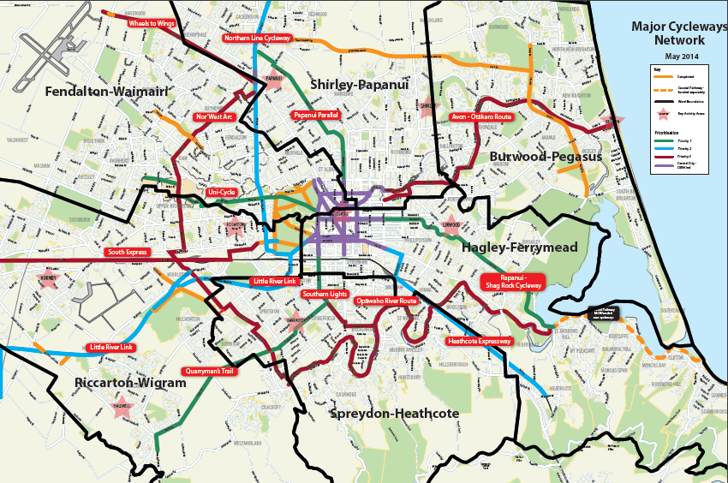
Figure 1: Figure captions go below a figure

Method
Give your paper a decent structure.

Findings
Present what you’ve done in a clear way.

What worked
Use second level headings if that’s useful.

What didn’t work
Don’t be afraid to talk about what didn’t work.

Discussion
If you use tables, refer to them in the text (refer to Table 1):
Table 1: Table captions go above a table

Conclusions
Finish the main part of your paper with conclusions or recommendations.

Acknowledgements
Provide these if necessary.

References
These must be referred to in the text. It is recommended they be listed in alphabetical order using the Harvard referencing system, summarised here:http://libguides.scu.edu.au/content.php?pid=269507&sid=2223205
Some examples of the Harvard system are below:

Book
HOYLE, B.S. and KNOWLES, R.D. (eds.) (2002). Modern Transport Geography, Belhaven Press, London.

Journal
NILSSON, G.K. (2001). Speeds increasing again, Nordic Road and Transport Research, 3, p.25.

Conference Paper
O’BRIEN, A. (1992). Safety audit for rural intersections, Workshop on Road Safety Audit, 14-16 April 1993, paper 6, Monash Transport Group, Clayton , Victoria.

Internet (example has no specific date)
Safer Journeys (n.d.). Safe Speeds, viewed 15 October 2015, <http://saferjourneys.govt.nz/areas-of-concern/safe-speeds/>
Reference in the text should be referred thus:
Nilsson (2001) stated . . . . .
O’Brien (1992, 1995) has shown. . . . .
. . . . . . speed contributed to over 30% of fatal crashes in New Zealand in 2008 (Safer Journeys, n.d.).
. . . . .according to several authors (Nilsson 2001; Smyth & Brown 2007; Walsh 2009).

Please note:
Up to three authors, shown as: BROWN A., SMITH, K. and GREEN, J. (2008)
More than three authors, shown as: BROWN A., et al. (2008)

Any editorial inquiries > 2WALKandCYCLE Conference Convenor
C/- Harding Conferences. Ph: 03 352 5598 or email glenda@hardingconsultants.co.nz

Declaration of competing interests
Please include a declaration of competing interests at the end of your paper on behalf of all authors. If there are no competing interests to declare, please state: “The author(s) declare(s) no competing financial interests.”

Appendices
Provide appendices if you wish.
Check the number of pages in the footer. If you have more than 12 pages at this point, your paper is too long. Cut it back to stay within that limit.

